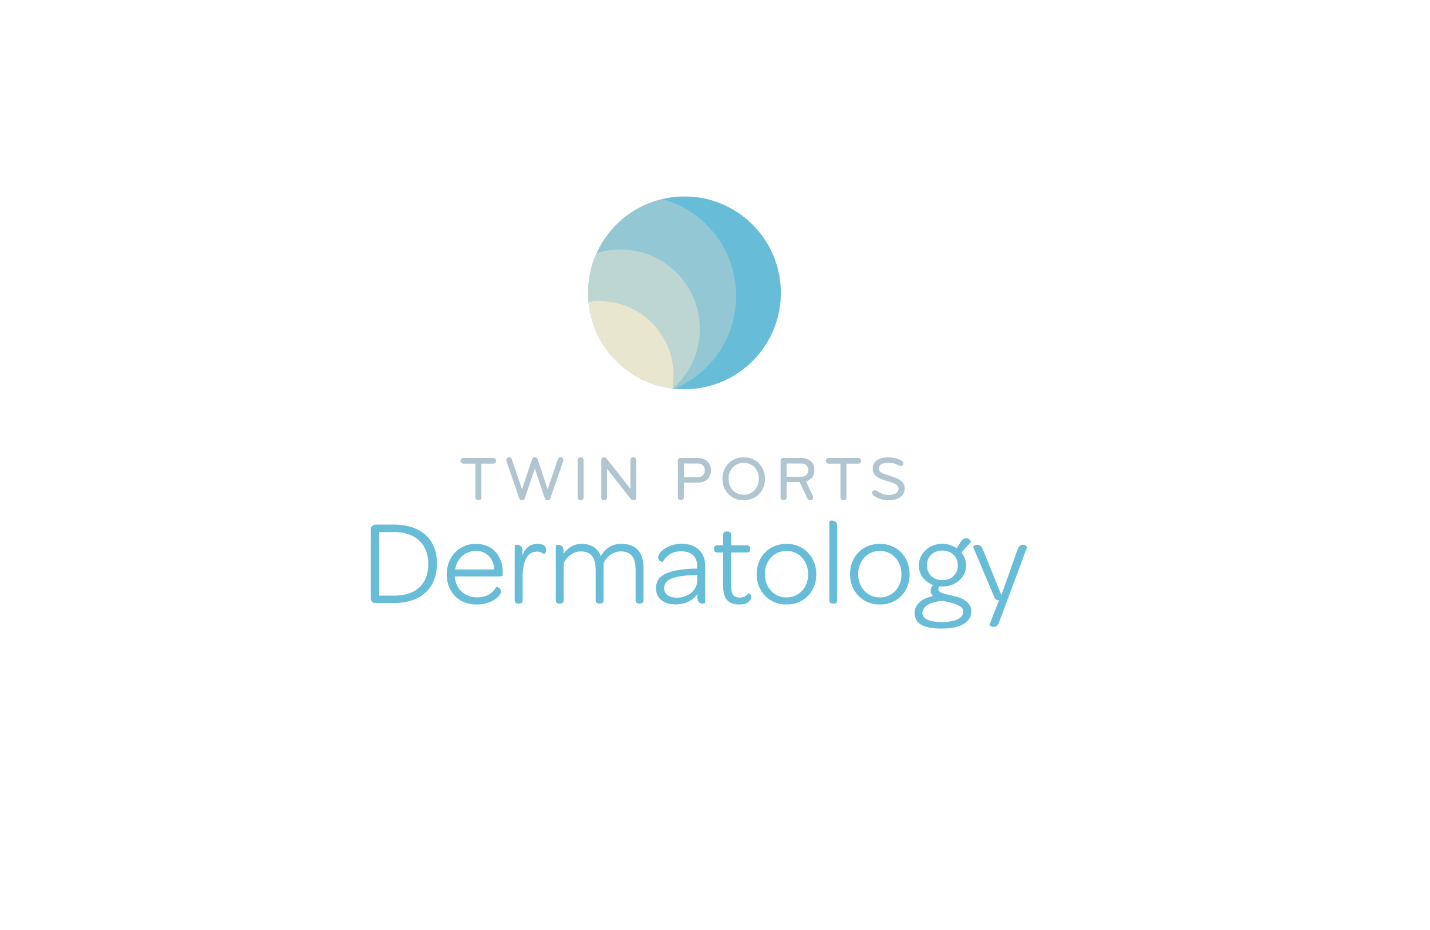
Patient Name __________________________ Phone ___________________ (scan as CS intake)
Date of Birth __________________________ Date of Consultation_________

The Critical Questions

How did you hear about the CoolSculpting procedure?

How did you hear about the practice?
CoolSculpting Specialist

What made you interested in the CoolSculpting procedure?

What area is troubling you the most?

Is there something special that you are trying to get ready for?

If there is a special event, what is the date?
TREATMENT CONSIDERATIONS form
The CoolSculpting® procedure is a non-invasive procedure that is intended to change the appearance of the treatment area by delivering controlled cooling at the surface of the skin to break down fat cells that are just beneath the skin. This procedure is not a treatment for obesity or a weight-loss solution. The CoolSculpting procedure does not replace traditional methods such as diet, exercise or liposuction. Initial:

Clinical studies of a treatment site have shown that the CoolSculpting procedure can break down fat cells to change the appearance of visibly localized bulges of fat that is just beneath the skin on the abdomen, thighs, flanks and submental area. The submental area is the area under the chin. Following the procedure, the treated fat cells are naturally processed by the body. Visible results can vary from person to person. Initial:

WHAT YOU CAN EXPECT:
Temporary Sensations / Symptoms:
» The suction pressure of a vacuum applicator may cause sensations of deep pulling, tugging and pinching. A
surface applicator may cause sensations of pressure. You may experience intense cold, stinging, tingling, aching
or cramping as the treatment begins. These sensations generally subside during treatment as the area becomes numb. Initial:

» You may have dizziness, light-headedness, nausea, flushing, sweating, or fainting during or immediately after the treatment. Initial:
»The treated area may look or feel stiff after the procedure and transient blanching (temporary whitening of the skin)
may occur. These are all normal reactions that typically resolve within a few minutes. Initial:

» Bruising, swelling, redness, cramping and pain can occur in the treated area and the treated area may appear red for one to two weeks after treatment. Initial:

» After submental area treatment, a feeling of fullness in the back of the throat may occur. Initial if the submental area is to be treated. If the area under the chin is not being treated, please write N/A. Initial:

» You may feel a dulling of sensation in the treated area that can last for several weeks after the procedure. Prolonged swelling, itching, tingling, numbness, tenderness to the touch, pain in the treated area, cramping, aching, bruising and/or skin sensitivity also have been reported. Initial:
Potential Side Effects / Risks
» Paradoxical Hyperplasia - A small number of patients have experienced gradual development of a firmer enlargement, of varying size and shape, of the treatment area, known as “paradoxical hyperplasia”, in the months following the treatment. If such paradoxical hyperplasia occurs, it will be distinguishable from temporary swelling and will probably not resolve on its own. The enlargement/lump can be removed by means of a surgical procedure such as liposuction. Initial: ________
» Treatment area demarcation- A small number of patients have experienced excessive fat removal in the treatment area, resulting in an unwanted indentation. The indentation may be improved through corrective procedures.
Initial: ________
» In rare cases, patients have reported the CoolSculpting treatment area to have darker skin color, hardness, discrete nodules, frostbite (local injury due to cold), hernia or worsening of pre-existing hernia. Surgical intervention may be required to correct hernia formation. Initial: ________
» Patient experiences may vary. Some patients may experience a delayed onset of the previously mentioned symptoms. Contact your physician immediately if any unusual side effects occur or if symptoms worsen over time. Initial:
» I understand that these and other unknown side effects may also occur. Initial:
Results
» You may start to see changes in as early as six weeks after your CoolSculpting procedure,and will experience the most dramatic results after one to three months. Your body will continue to naturally process the injured fat cells from your body for approximately four months after your procedure. Initial:

» Results vary from person to person. Unfortunately, non-responders do happen, no different than with other cosmetic procedures. It is extremely rare with CoolSculpting but there is a less than a 1% non-responder rate. Most cases of patients being “non- responders” are simply patients that have been under-treated, gained weight, or their expectations are not realistic. If a patient performs less than the recommended cycles, they may not see the full result they are looking for. There are no refunds of treatments performed. Initial:
Do you currently have or have had any of the following?
» Cryoglobulinemia (a condition in which an abnormal level of proteins thicken the blood in cold temperatures), or paroxysmal cold hemoglobinuria or cold agglutinin disease (blood disorders in which cold temperatures lead to red blood cell death). ……………………………………………………………………………………………………………………..…..Yes / No

» Known sensitivity to cold such as cold urticaria (hives triggered by cold), Raynaud’s disease (disorder in which cold leads to reduced blood flow in the fingers, which appear white, red, or blue), pernio or Chilblains (itchy and/or tender red or purple bumps that occur as a reaction to cold). ……………………………………………………..……………………..Yes / No
» Poor blood flow in the area to be treated…………….………………………..…………………………………..Yes / No
» Neuropathic (nerve) disorders such as post-herpetic neuralgia or diabetic neuropathy……...……………….Yes / No
» Impaired skin sensation ……………………………………………………………………………………...…….Yes / No
» Open or infected wounds …………………………………………………………………………..……………...Yes / No
» Bleeding disorders or use of blood thinners …………………………………………………………………..….Yes / No
» Recent surgery or scar tissue in the area to be treated………………………………………..………………...Yes / No
» A hernia or history of hernia in the area to be treated or adjacent to treatment site …………………………..Yes / No
» Skin conditions such as eczema, dermatitis, or rashes………………………………………………..………...Yes / No
» Pregnancy or lactation (making breast milk or breast feeding) ……………………………………………...….Yes / No
» Any active implanted devices such as pacemakers and defibrillators ………….……………………………...Yes / No
» Any major health problems such as liver disease …………………………………..…………………..……….Yes / No
» Any known sensitivity to isopropyl alcohol (rubbing alcohol) or propylene glycol …………………….……….Yes / No

Pictures will be obtained for medical records. If pictures are used for education and marketing purposes, all identifying marks will be cropped or removed. Initial:

WE REQUIRE A $250 DEPOSIT FOR A HALF DAY APPOINTENT, $500 FOR A FULL DAY APPOINTMENT WHICH WILL BE APPLIED TOWARD YOUR BALANCE. THIS IS NON-REFUNDABLE IF CANCELED OR RESCHEDULED IN LESS THAN 24 HOURS.
IF YOUR APPOINTMENT IS CANCELED IN LESS THAN 5 BUSINESS DAYS, YOUR DEPOSIT WILL BE KEPT AS A CREDIT ON ACCOUNT. Initial:_________

